**JSPM’Narhe Technical Campus**

**Master of Computer Applications(MCA)**

**Subject Name:-Mobile Application Development - (IT-31)**

**MCA-I SEM-II**

Assignment No-1

Assignment Declaration Date:- 25/01/2022 Assignment Submission Date:-5/02/2022

Assignment assessment declaration Date by faculty: 25/01/2022

**Solve any five Questions**

|  |  |  |  |  |  |  |
| --- | --- | --- | --- | --- | --- | --- |
| **Q.No** | **Question Statement** | **Level of Mapping & Number** | | | **Blooms Level** | **Marks** |
|  |  | CO | PO | PSO |  |  |
| 1 | Explain what is the activity and activity life cycle in details? | 2 | PO-2 | PSO-1 | 1 | 5 |
| 2 | What is fragment? Explain fragment life cycle in details? | 2 | PO-2, | PSO-1 | 6 | 5 |
| 3 | What is view? | 2 | PO-2 | PSO-2 | 5 | 5 |
| 4 | What is view Group? | 2 | PO-1,  PO-3 | PSO-2 | 3 | 5 |
| 5 | **Draw the diagram of Activity Life Cycle?** | 2 | PO-2  PO-3 | PSO-1 | 2 | 5 |

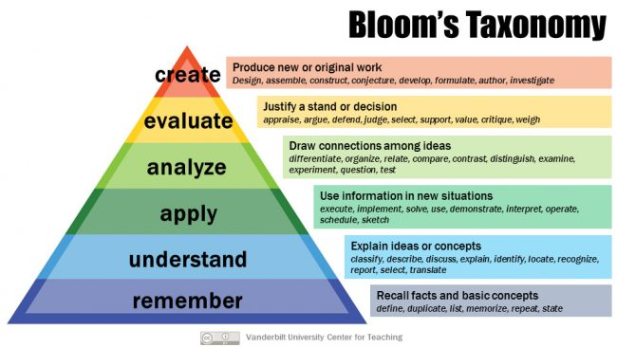

**Subject In-charge Dean**